|  |  |
| --- | --- |
| **NAME** | SABARI S |
|  |  |
| **REGISTER NUMBER** | 812620243018 |
|  |  |
| **NM ID** | 860EA13909FA6DAB93445590D3FC2710 |
|  |  |
|  |  |
|  | **ASSIGNMENT - 2** |
|  |  |

**Task**

Upload the dataset to Cognos Analytics, prepare the data, explore and Create Interactive Dashboard, Report and Story.

**Problem Statement:-**

The Cognos HR Scorecard: Measuring Success in Talent Management.

HR data can be hard to come by, and HR professionals generally lag behind with respect to analytics and data visualization competency. We use the data set to teach HR students show to use and analyze the data in Cognos - a data visualization tool that's easy to learn.

**Overall Dashboard**

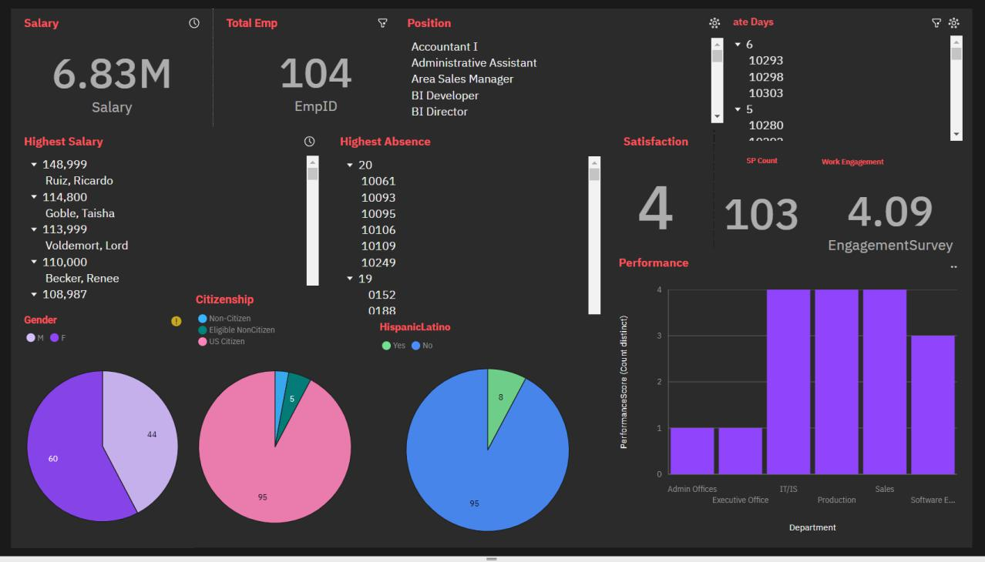

**Female Employees**

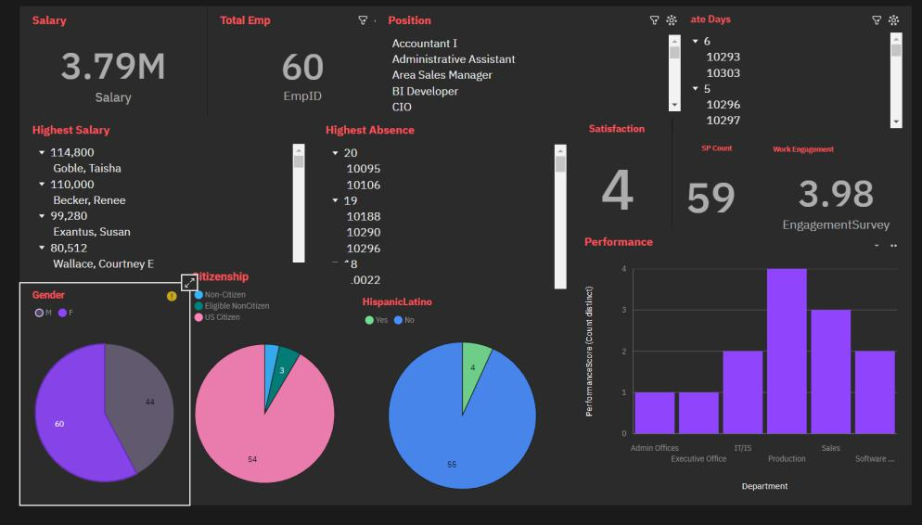

**Male Employees**

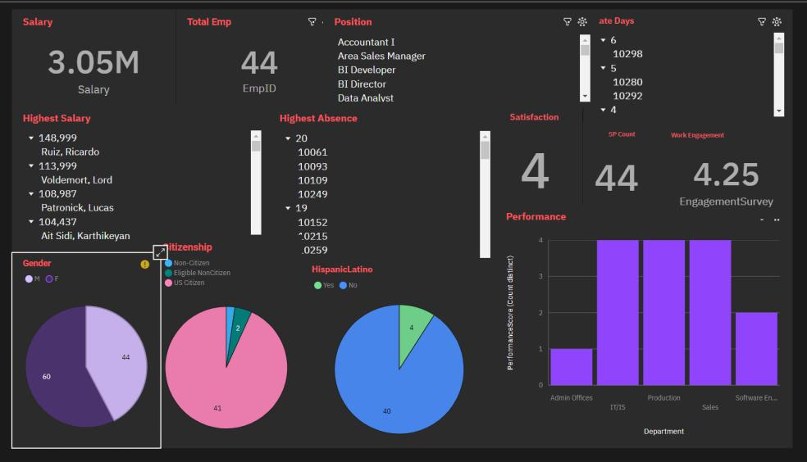

**Data Analyst Employee**

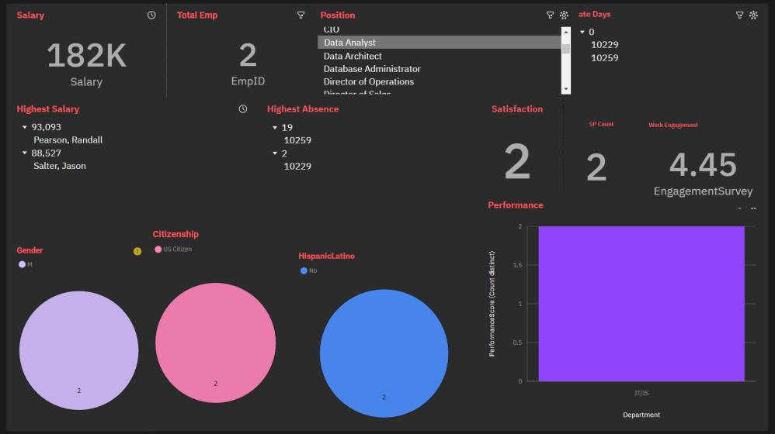

**Search Dashboard**

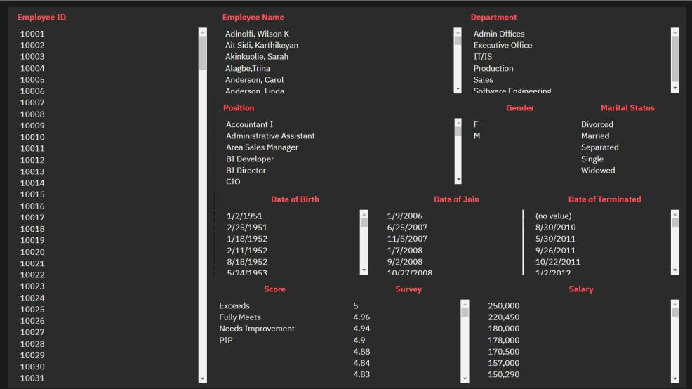

**Search with Employee ID**

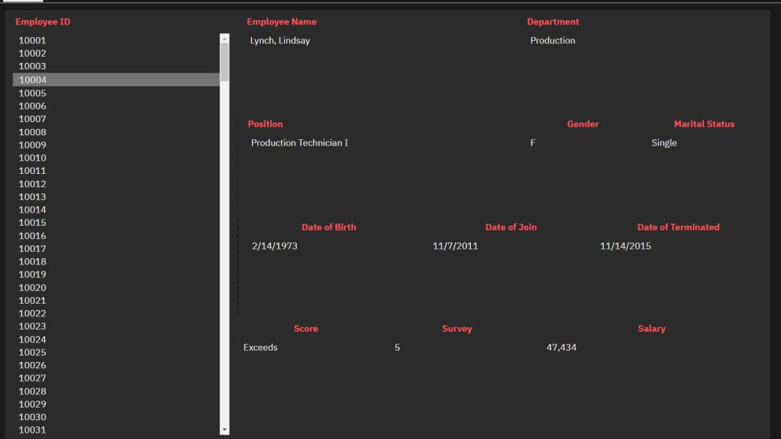

**Search with Performance Score**

